Comparative Implementation and Performance Analysis of Two Deep Learning-Based
Frameworks for Automatic Optic Disc and Optic Cup Segmentation
Towards Early Glaucoma Screening Using Fundus Images

Integrating a Multi-Class U-Net with Guided Holistically-Nested Edge Detection (HED) and Adaptive Snake Refinement, and an Enhanced CSP-SegNet Framework for Accurate Retinal Structure Segmentation

Submitted By
Gyandeep Talukder

Submitted To
Dr. Durgesh Singh

Research Internship Completed At
Indian Institute of Information Technology,
Design and Manufacturing (IIITDM), Jabalpur

Department of Computer Science and Engineering
Academic Session: 2026–2027

ACKNOWLEDGEMENT
I would like to express my sincere gratitude to Dr. Durgesh Singh, Indian Institute of Information Technology, Design and Manufacturing (IIITDM), Jabalpur, for his invaluable guidance, encouragement, and constant support throughout my research internship. I am deeply thankful to my mentor, Mr. Abhishek Chauhan, for his continuous technical guidance, insightful suggestions, and constructive feedback, which greatly contributed to the successful completion of this work. I also extend my heartfelt appreciation to Mr. Ankur Mudgal for providing me with the opportunity to undertake this internship and gain valuable research experience. I am grateful to the Department of Computer Science and Engineering, Jaypee University of Engineering and Technology (JUET), Guna, for providing me with a strong academic foundation and continuous encouragement. I further acknowledge the authors of the research papers, the developers of the open-source deep learning frameworks, and the providers of the REFUGE and DRISHTI-GS retinal image datasets, whose resources were instrumental in this study. Finally, I express my sincere gratitude to my parents, family, and friends for their unwavering support, encouragement, and motivation throughout the successful completion of my internship and this report.
Table of Contents
Abstract 4
1. Introduction 4
2. Problem Statement 5
3. Literature Review 5
4. Dataset Description 6
5. Methodology 7
5.1 Report 1 — U-Net + Guided HED + Adaptive Snake Pipeline 7
5.2 Report 2 — CSP-SegNet+E 8
6. Experimental Results and Discussion 10
6.1 Report 1 — U-Net + Snake vs. Reference Hybrid Method (REFUGE) 10
6.2 Report 2 — CSP-SegNet+E on REFUGE (in-domain) 10
6.3 Report 2 — Cross-Dataset Generalisation (DRISHTI-GS, zero-shot) 11
6.4 Cross-Report Comparison 11
7. Novel Contribution 11
7.1 Report 1's Novelty (relative to the reference paper) 11
7.2 Report 2's Novelty — Edge-Supervised Auxiliary Branch 11
8. Advantages and Limitations 12
8.1 Report 1 — U-Net + Guided HED + Adaptive Snake 12
8.2 Report 2 — CSP-SegNet+E 12
10. Conclusion 13

Abstract
Glaucoma is one of the leading causes of irreversible blindness worldwide, and its progression is routinely tracked using the cup-to-disc ratio (CDR), which depends on accurately outlining the optic disc (OD) and optic cup (OC) in colour fundus photographs. Manual delineation by ophthalmologists is accurate but slow, expertise-heavy, and inconsistent between observers, motivating automated segmentation.
This combined work presents two related approaches developed on the REFUGE/REFUGE2 dataset:
- A Multi-Class U-Net + Guided HED + Adaptive Snake pipeline — a single 3-class U-Net (background/disc/cup) followed by connected-component cleanup, a disc-restricted Holistically-Nested Edge Detection (HED) edge map, an adaptive active-contour (snake) refinement with a collapse-safety fallback, morphological smoothing, and a hard anatomical constraint that forces the cup to stay inside the disc. It is benchmarked against a reference hybrid U-Net+HED+Snake paper (Hajrasooliha & Naghsh-Nilchi, 2026).
- CSP-SegNet+E — a lightweight (1.52M-parameter) encoder-decoder built from depthwise-separable convolutions, Squeeze-and-Excitation (SE) blocks, Inverted Residual Blocks (IRBs), and Channel-Spatial-Pixel (CSP) attention, extended with a novel Edge-Supervised Auxiliary Branch. This second decoder head is trained jointly with the segmentation head using Sobel-derived boundary maps (needing no extra manual annotation), under a combined Dice + IoU + edge binary-cross-entropy loss.
On REFUGE, CSP-SegNet+E achieves an Optic Cup Dice of 0.822 (IoU 0.699) and Optic Disc Dice of 0.779 (IoU 0.639), with mean foreground Dice of 0.795. A zero-shot cross-dataset test on 51 DRISHTI-GS images shows a large domain-shift drop (Cup Dice 0.334, Disc Dice 0.301). The U-Net + Snake pipeline, evaluated on its own REFUGE split, obtains Disc Dice 0.611 and Cup Dice 0.654, trailing the reference paper on Dice/IoU but outperforming it on Cup HD95 (boundary distance), and additionally reports Cup-to-Disc Ratio (CDR) agreement not provided by the reference study. Together, the two efforts explore complementary directions — post-hoc geometric/contour refinement versus in-network edge supervision — toward more boundary-accurate, clinically usable optic disc/cup segmentation.

1. Introduction
Glaucoma is a group of progressive optic neuropathies and one of the leading causes of irreversible vision loss globally. Because early-stage glaucoma is largely symptom-free, population-scale screening matters, and colour fundus photography is the cheapest, most widely used tool for it. Clinically, glaucomatous damage is estimated through the cup-to-disc ratio (CDR): the ratio of the optic cup's vertical extent to the optic disc's vertical extent, measured through the same central axis. A larger CDR generally signals a thinner neuro-retinal rim and a higher chance of glaucomatous damage, though it is usually interpreted alongside other clinical indicators rather than in isolation.
Manual annotation of the disc and cup by ophthalmologists does not scale to population screening — it is slow, requires specialist training, and is subject to real inter- and intra-observer disagreement, especially along the cup boundary, where the depth cue is subtle in a flat 2-D photo. This has driven three decades of research from classical edge/intensity-based methods toward deep convolutional encoder-decoder networks that learn the segmentation directly from annotated data.
Both efforts summarised in this report follow the same broad recipe — deep network initialization followed by boundary refinement — but push on two different weak points of existing pipelines:
- Report 1 targets the post-processing / contour-refinement stage: even after a good initial network prediction, active-contour (snake) refinement can be unstable, and disc/cup masks can end up anatomically implausible (e.g., cup pixels appearing outside the disc). This pipeline adds guided edge detection, a safer/adaptive snake, and a hard anatomical constraint to fix this.
- Report 2 targets the training objective itself: region-overlap losses like Dice/IoU do not explicitly penalise boundary displacement, so two masks with similar Dice can still have very different, clinically meaningful contour errors. CSP-SegNet+E adds an auxiliary edge-prediction head, trained with automatically generated Sobel boundary maps, to push the network's shared features to be boundary-aware from the start.
Together they represent two complementary strategies for the same underlying problem: fixing boundary accuracy after the network runs (Report 1) versus baking boundary awareness into training (Report 2).

2. Problem Statement
Accurate, automatic segmentation of the optic disc and optic cup in fundus images is difficult for several concrete reasons:
- Low-contrast, ambiguous cup boundary — the optic cup edge is a subtle intensity/depth transition, often partially occluded by blood vessels, making it the primary source of segmentation error and inter-observer disagreement.
- Severe class imbalance — background pixels vastly outnumber disc and cup pixels; a network can achieve deceptively high pixel accuracy while failing on the diagnostically important foreground classes.
- Boundary-insensitive losses — standard region losses (Dice, IoU, cross-entropy) treat every misclassified pixel equally regardless of its distance from the true boundary.
- Anatomical validity is not guaranteed by construction — a network or contour refinement can produce a cup mask that incorrectly extends outside the disc mask unless this constraint is explicitly enforced.
- Active-contour instability — classical snake/GVF refinement can collapse or shrink pathologically on weak/noisy edges if left unchecked.
- Cross-dataset (domain-shift) generalisation — models trained on one dataset typically lose significant accuracy when applied, without retraining, to a different camera/population.
- Deployment constraints — screening, especially in low-resource settings, requires models lightweight enough to run on modest hardware while remaining accurate enough for reliable triage.
Both reports aim to improve segmentation accuracy and boundary quality under these constraints, while keeping the underlying networks lightweight and reproducible.

3. Literature Review
Classical methods.
Early optic disc/cup localisation relied on hand-crafted cues — colour thresholding, the circular Hough transform, active contours, and superpixel classification — exploiting the fact that the disc is typically the brightest, roughly elliptical region in a fundus image. These methods were computationally cheap but fragile to illumination changes, peripapillary atrophy, and vessels crossing the cup boundary, and usually needed disc localisation as a separate step before cup segmentation. Level-set and active-contour formulations tried to address some of this by evolving a boundary under an energy functional, but they need careful initialisation near the true boundary and remain sensitive to low-contrast cup edges.
Deep encoder-decoder networks.
Fully convolutional networks shifted the field to end-to-end learning. U-Net established the now-standard encoder-decoder-with-skip-connections design, which remains a strong baseline because skip connections preserve the fine spatial detail needed for thin, low-contrast boundaries. Attention U-Net added attention gates to suppress irrelevant background before feature fusion. CE-Net inserted dense atrous convolution and residual multi-kernel pooling blocks between encoder and decoder to recover context lost to pooling. DeepLabV3+ used atrous (dilated) convolutions to capture multi-scale context while preserving resolution.
Lightweight architectures.
A parallel line of work focuses on making networks deployable on resource-constrained screening hardware. MobileNet-style depthwise-separable convolutions and inverted residual blocks with linear bottlenecks drastically cut parameter count and compute. Squeeze-and-Excitation (SE) blocks recalibrate channel-wise responses cheaply. CSPNet's Cross-Stage-Partial connections reduce redundant gradient information while improving learning capacity — later repurposed as the Channel-Spatial-Pixel (CSP) attention formulation used in the reference CSP-SegNet architecture that Report 2 builds on.
Boundary-aware / edge-supervised segmentation.
Because pixel-wise losses (cross-entropy, Dice, IoU) treat every misclassified pixel the same regardless of distance from the true edge, several works add auxiliary boundary-prediction branches, boundary-weighted losses, or distance-transform supervision as a multi-task regulariser. BEAL (Boundary and Entropy-driven Adversarial Learning) is particularly relevant, combining boundary supervision with adversarial domain alignment and showing that boundary information helps both in-domain accuracy and cross-dataset generalisation.
Joint disc/cup-specific architectures.
M-Net performs a polar-coordinate transform around the disc centre (turning roughly circular boundaries into nearly linear ones) and jointly regresses CDR. pOSAL targets cross-domain generalisation via adversarial output-space alignment. More recently, transformer and hybrid CNN-transformer designs (e.g., TransUNet) add long-range context via self-attention while keeping convolutional skip connections for fine localisation.
HED and active contours (Report 1's reference method).
The reference paper compared against in Report 1 (Hajrasooliha & Naghsh-Nilchi, 2026) proposes a hybrid framework: two separate lightweight U-Nets (one per structure), an unrestricted Holistically-Nested Edge Detection (HED) map over the whole ROI, and a classical GVF-snake refinement with globally fixed parameters. Report 1's implementation follows the same conceptual family but changes several concrete design choices, detailed in Section 7.
Benchmarks.
REFUGE (Retinal Fundus Glaucoma Challenge) is a standard benchmark providing pixel-level disc/cup annotations plus glaucoma diagnostic labels. DRISHTI-GS provides expert-annotated boundaries from a different camera/population and is commonly used to test cross-dataset generalisation of models trained elsewhere — exactly the evaluation performed in Report 2.

4. Dataset Description
REFUGE / REFUGE2 (used by both reports)
A large, publicly released benchmark for glaucoma-related fundus image analysis with colour fundus photographs and pixel-level optic disc/cup ground truth.
- Organised into train, validation, and test splits, each containing 400 paired image/mask samples (Report 2); Report 1 similarly loads train/validation/test splits from a REFUGE/REFUGE2 archive mounted from Google Drive.
- Ground-truth masks follow the standard REFUGE greyscale convention: pixel intensity 0 = optic cup, 128 = optic disc (excluding cup), 255 = background — verified directly on the loaded masks.
- Images are resized to a fixed working resolution (256×256 in Report 2; a configurable IMG_HEIGHT×WIDTH in Report 1), converted to RGB, and normalised to [0, 1].
- Image-mask pairs are matched automatically by filename stem across supported extensions.
DRISHTI-GS (used only in Report 2)
A separate fundus dataset with expert-marked disc/cup boundaries, collected with different cameras, populations, and protocols than REFUGE.
- Used exclusively as an unseen, out-of-distribution test set — the network is not fine-tuned or retrained on it.
- 51 image-mask pairs were successfully matched and evaluated, using the same preprocessing pipeline (resize to 256×256, RGB normalisation, re-encoding into the shared Cup/Disc/Background convention) as REFUGE.
Dataset preparation challenges (Report 2)
- Severe pixel-level class imbalance — background pixels vastly outnumber disc, and especially cup, pixels — motivating class-weighted, per-class loss formulations rather than pooling all pixels together.
- REFUGE and DRISHTI-GS use different raw mask-encoding conventions and file formats, requiring a dataset-specific loader for each source that both re-encode into the same shared three-class one-hot representation.
Dataset Summary Table (Report 2)
Dataset / Split | Samples | Content | Role
REFUGE (train) | 400 | Fundus RGB + Cup/Disc mask | Training
REFUGE (val) | 400 | Fundus RGB + Cup/Disc mask | Validation
REFUGE (test) | 400 | Fundus RGB + Cup/Disc mask | In-domain test
DRISHTI-GS (test) | 51 | Fundus RGB + Cup/Disc mask | Cross-dataset test

5. Methodology

5.1 Report 1 — U-Net + Guided HED + Adaptive Snake Pipeline
The overall pipeline is: Fundus Image → ROI Extraction → Laplacian Sharpening → Resize/Normalize → Multi-class U-Net (Background/Disc/Cup) → Small False-Positive Removal → Guided HED Edge Map (disc region only) → Adaptive Snake Refinement → Morphological Closing/Opening → Anatomical Constraint (Cup-inside-Disc) → Final Masks → Evaluation (Dice, IoU, HD95, CDR).
Preprocessing
- ROI extraction: threshold, find the largest external contour, crop to its bounding box to remove the black fundus-camera border.
- Laplacian sharpening: subtract a Laplacian filter response from the image (clipped to [0,255]) to sharpen disc/cup boundary edges before resizing.
- Resize & normalize to the target resolution with INTER_AREA interpolation, scaled to [0,1].
- Augmentation: Keras ImageDataGenerator applies rotation (±15°), width/height shift (10%), zoom (15%), and horizontal flip.
- Ground-truth masks are merged into a single multi-class label map (0=background, 1=disc, 2=cup) and one-hot encoded to match the network's softmax output.
- Preprocessed data is wrapped in a tf.data.Dataset with shuffle, batch, and prefetch for efficient training.
Model — Multi-Class U-Net
A single lightweight U-Net built with the Keras functional API — 4 encoder stages (32→64→128→256 filters) with max-pooling and skip connections, a 512-filter bottleneck, 4 decoder stages using transposed-convolution upsampling, and a final 1×1 Conv2D + softmax head over 3 classes. Mixed precision (float16 compute/float32 variables) is used for faster GPU training. Training uses Adam with EarlyStopping, ReduceLROnPlateau, and ModelCheckpoint callbacks.
Prediction
The 3-channel softmax is converted to a class-label map via argmax; disc and cup binary masks are extracted as class==1 and class==2 respectively.
Post-processing / boundary refinement (the main novelty area)
- Small false-positive removal — connected-components filtering keeps only the largest blob in each predicted mask.
- Guided HED edge detection — a pretrained HED (Holistically-Nested Edge Detection) Caffe model, loaded via OpenCV's DNN module, is run only on the disc region (masked and hole-filled first), rather than on the whole image, to avoid vessel/background clutter distracting the edge map.
- Adaptive snake refinement — the disc contour is resampled to a fixed number of uniformly spaced points, pre-expanded outward along local normals, and refined using skimage.segmentation.active_contour on a Gaussian-smoothed, inverted edge-energy landscape (fixed hyperparameters: alpha=0.01, beta=5, gamma=0.001, 600 iterations). A collapse-detection fallback reverts to the plain U-Net mask if the optimized contour shrinks below 30% of the original area.
- Morphological regularization — disc: close then open with a 7×7 elliptical kernel plus largest-component filtering; cup: largest-component filtering, then close/open with a 5×5 kernel.
- Anatomical constraint — the refined cup mask is intersected with the refined disc mask (cv2.bitwise_and), guaranteeing no cup pixel falls outside the disc.
Evaluation metrics
Dice coefficient, IoU (Jaccard), HD95 (95th-percentile bidirectional Hausdorff distance), and vertical Cup-to-Disc Ratio (CDR), computed per image and averaged, collected into a pandas DataFrame for comparison against the reference paper's reporting style.

5.2 Report 2 — CSP-SegNet+E
Data pipeline (six stages)
Dataset inspection/automatic image-mask pairing → image/mask preprocessing → multiclass mask encoding → edge ground-truth generation → in-memory dataset preloading with tf.data → augmentation.
- Images: BGR→RGB, resized to 256×256 with bilinear interpolation, normalised to [0,1]. Masks: resized with nearest-neighbour interpolation to avoid intermediate label values at boundaries.
- Masks are re-encoded into a 3-class one-hot representation: 0=Optic Cup, 1=Optic Disc, 2=Background.
- Edge ground-truth generation (key novelty input): the categorical label map is recovered via argmax of the one-hot mask, a Sobel operator computes horizontal/vertical gradients, the gradient magnitude is taken as the Euclidean norm, and any non-zero-gradient pixel is marked as a boundary pixel — producing a binary (256,256,1) edge map with no additional manual annotation required.
- The full preprocessed dataset (images, one-hot masks, edge maps) is preloaded into in-memory NumPy tensors, wrapped in tf.data.Dataset with training targets as a dictionary {"segmentation_output": masks, "edge_output": edges}, using batch size 16 with shuffling and prefetching.
- Augmentation: random horizontal/vertical flips applied identically to image, mask, and edge map to keep them spatially aligned.
- Implemented in TensorFlow 2.20 / Keras 3.13, with a verification-first workflow (checking mask value conventions, tensor shapes, and visualised samples before full training runs).
Architecture — CSP-SegNet+E
A symmetric encoder-decoder with 4 encoder stages (32→64→128→256 channels), a bottleneck, and 4 mirrored decoder stages with skip connections. Each encoder stage is: depthwise-separable 3×3 convolution → BatchNorm/ReLU → Squeeze-and-Excitation (SE) block → Inverted Residual Block (IRB) → CSP (Channel-Spatial-Pixel) attention module → 2×2 max pooling. The decoder mirrors this, upsampling and concatenating the corresponding CSP-attended encoder skip connection at each stage.
Two parallel 1×1 convolutional output heads sit on the shared decoder representation:
- Segmentation head: 3-channel softmax over {Cup, Disc, Background}.
- Edge auxiliary head (the novel component): 1-channel sigmoid predicting per-pixel boundary probability.
Total network size: 1,524,990 trainable parameters — well below typical U-Net (~30M) or DeepLabV3+ with ResNet-101 (~40M+) baselines.
Loss functions
- Region losses: soft Dice loss + soft IoU loss, summed as L_seg. A class-weighted, per-class variant (weights 2.0 Cup / 1.5 Disc / 0.5 Background) is also monitored to counter class imbalance.
- Edge loss: standard per-pixel binary cross-entropy between predicted and Sobel-derived ground-truth edge maps.
- Joint objective: L_total = λ_seg · L_seg + λ_edge · L_edge, with λ_seg = 1.0 and λ_edge = 0.3 (edge task kept subordinate to the primary segmentation objective).
Training setup
Adam optimizer, initial LR 0.001, ReduceLROnPlateau (factor 0.5, patience 5), EarlyStopping (patience 12, restore best weights), ModelCheckpoint on validation mean-foreground-Dice, up to 60 epochs, batch size 16.
Evaluation metrics
Per-class Dice, IoU, precision, and recall; plus a clinically motivated mean foreground Dice (average of Cup and Disc Dice only, excluding the trivially easy background class).

6. Experimental Results and Discussion

6.1 Report 1 — U-Net + Snake vs. Reference Hybrid Method (REFUGE)
Metric | Reference Paper (U-Net+HED+Snake) | Proposed (Report 1) Framework
Disc Dice | 0.9527 | 0.6105
Cup Dice | 0.7966 | 0.6540
Disc IoU | 0.9109 | 0.4535
Cup IoU | 0.6737 | 0.5384
Disc HD95 (px) | 4.18 | 6.18
Cup HD95 (px) | 8.35 | 2.83
Average GT CDR | Not reported | 0.4463
Average Predicted CDR | Not reported | 0.4083

The Report 1 pipeline trails the reference paper on Disc Dice/IoU and Disc HD95, and on Cup Dice/IoU, but achieves a notably better Cup HD95 (2.83 vs 8.35 pixels), suggesting its cup boundary, while less complete in area overlap, tracks the true contour more tightly at the pixel-distance level. It is also the only one of the two to report CDR agreement (GT vs predicted), which is not given in the reference paper.

6.2 Report 2 — CSP-SegNet+E on REFUGE (in-domain)
Class | Dice | IoU | Precision | Recall
Optic Cup | 0.835817 | 0.7179 | 0.880751 | 0.79524
Optic Disc | 0.820139 | 0.69511 | 0.8758 | 0.771077
Background | 0.9985 | 0.99700 | 0.9975 | 0.999420

The Cup shows higher recall than precision (mild over-segmentation), while the Disc shows the opposite — higher precision than recall (mild under-segmentation). This matches the relative visual difficulty of the two structures: the disc edge is high-contrast so the network is conservative, while the low-contrast cup boundary is more prone to over-estimation near vessel occlusion. Training/validation loss and Dice curves rose together without a strong divergence, suggesting augmentation, LR scheduling, and early stopping controlled overfitting reasonably well given the moderate (400-image) training set.

6.3 Report 2 — Cross-Dataset Generalisation (DRISHTI-GS, zero-shot)
Class | Average Dice | Average IoU
Optic Cup | 0.5673438268389802 | 0.4233963148719385
Optic Disc | 0.5225004521630128 | 0.3833507571770326

This is a large drop from the in-domain REFUGE scores (0.822/0.779), quantifying a substantial domain-shift gap consistent with known sensitivity of fundus segmentation networks to changes in camera, illumination, field of view, and population between acquisition sites.

6.4 Cross-Report Comparison
Both efforts converge on similar in-domain cup accuracy in the mid-0.6 to 0.8 Dice range but differ sharply in disc accuracy: CSP-SegNet+E's Disc Dice (0.779) is much higher than Report 1's post-processed Disc Dice (0.611), which trades off Dice/IoU against tighter Cup boundary distance (HD95). This is consistent with the two systems optimizing for different things — CSP-SegNet+E optimizes region overlap directly with edge-supervised regularisation baked into training, whereas Report 1's snake-refinement stage explicitly targets boundary geometry and anatomical validity, sometimes at the cost of overall area overlap.

7. Novel Contribution

7.1 Report 1's Novelty (relative to the Hajrasooliha & Naghsh-Nilchi reference paper)
- Single multi-class network instead of two binary networks — one shared 3-class U-Net replaces two separate disc/cup U-Nets, halving trained models and enforcing class consistency through shared features.
- Disc-restricted, hole-filled HED guidance — HED edge detection is masked to run only on the (hole-filled) predicted disc region, rather than the whole ROI, so it isn't distracted by vessels or background clutter — a form of prediction-guided attention absent from the reference method.
- Outward-expanding, resampled, fallback-protected snake — the contour is resampled to uniform spacing, pre-expanded outward so the snake can converge from inside the mask, and protected by a collapse-detection fallback (reverting to the U-Net mask if the polygon shrinks below 30% of its initial area) — an adaptive safeguard with no counterpart in the reference paper.
- Explicit small-object and morphological cleanup stage — connected-components filtering both after U-Net prediction and after snake refinement, plus structure-specific morphological kernels (7×7 disc, 5×5 cup).
- Hard anatomical constraint (Cup ⊆ Disc) — pixel-level intersection of cup and disc masks guarantees anatomically valid CDR by construction, rather than relying on the network/snake to learn this implicitly.
- Toward CSP-SegNet+E (forward-looking link to Report 2) — the report explicitly identifies extending toward an edge-supervised auxiliary branch trained on Sobel boundary maps as the next stage of this work, directly foreshadowing Report 2's contribution.

7.2 Report 2's Novelty — Edge-Supervised Auxiliary Branch
The principal contribution is the "+E" in CSP-SegNet+E: a second decoder head that predicts a binary edge/boundary map, trained jointly with the segmentation head via a shared encoder-decoder backbone. Because region losses (Dice/IoU) are insensitive to small systematic boundary offsets as long as overall overlap is high, this auxiliary task explicitly regularises the shared representation to also be boundary-accurate.
Key advantages of this design over alternatives (a fully separate boundary network, or an explicit boundary-weighted region loss):
- Negligible parameter/inference overhead — the edge head is a single extra 1×1 convolution and can be discarded after training if unneeded at deployment.
- No additional annotation — the edge ground truth is generated automatically and deterministically (via Sobel gradients) from existing region masks.
- Tunable auxiliary strength — the edge loss weight (0.3 vs. 1.0 for segmentation) lets the boundary regularisation assist without dominating optimisation.
Theoretically, this is framed as hard parameter sharing / inductive-bias injection: because a region's boundary is fully determined by its mask (and vice versa), the two tasks are tightly coupled, giving a principled reason to expect the edge branch to sharpen rather than distract from the segmentation objective.

8. Advantages and Limitations

8.1 Report 1 — U-Net + Guided HED + Adaptive Snake
Advantages
- Guarantees anatomically valid masks by construction (cup can never appear outside the disc).
- Explicit safeguards against a known failure mode of active contours (energy-driven collapse on weak/noisy edges).
- Disc-restricted HED guidance reduces distraction from vessels/background clutter.
- Reports CDR agreement, directly relevant to the clinical use case, which the reference paper omits.
- Achieves notably tighter cup boundary distance (HD95) than the reference method.
Limitations
- Trails the reference paper substantially on Disc Dice/IoU and on Disc HD95.
- Relies on a pretrained, somewhat dated Caffe-based HED model requiring a custom re-registered crop layer, adding engineering complexity/fragility.
- Fixed snake hyperparameters (alpha, beta, gamma, iteration count) are not learned or tuned per-image.
- Two proposed CG-AVM (Clinically-Guided Anatomical Validation Module) elements — disc-shape plausibility scoring and an explicit CDR-range validation gate — are computed as metrics but not yet used as active correction/rejection rules.

8.2 Report 2 — CSP-SegNet+E
Advantages
- Very lightweight (1.52M parameters) relative to typical segmentation backbones (U-Net ~30M, DeepLabV3+/ResNet-101 ~40M+), suitable for edge/low-resource deployment.
- Edge supervision requires no extra manual annotation (derived automatically via Sobel gradients from existing masks).
- Competitive in-domain Cup Dice (0.822) despite the small parameter budget.
- Reports a full, standardised metric suite (Dice, IoU, precision, recall) separately per class, exposing asymmetric error patterns that a single pooled score would hide.
Limitations
- No direct ablation yet against a single-head (segmentation-only) baseline — so the edge branch's quantitative benefit, while theoretically motivated, is not yet numerically isolated.
- Large cross-dataset (DRISHTI-GS) accuracy drop (Cup Dice 0.334, Disc Dice 0.301) shows poor out-of-the-box generalisation to different cameras/populations.
- Training/validation sets are moderate in size (400 images each), which may limit performance and increase sensitivity to further augmentation or data.
- Sobel-derived edge ground truth is a simple gradient-based approximation that doesn't model annotation uncertainty near the (naturally ambiguous) cup contour.
- Only one training run is reported (no repeated runs across random seeds), so point estimates should be read as representative rather than precise population statistics.
- Optic Disc Dice (0.779) falls below typical ranges reported in the wider literature (high 0.90s), plausibly because disc-centred ROI cropping — common in comparable studies — was intentionally omitted here to keep the pipeline simple and end-to-end.

10. Conclusion
Both reports advance automatic optic disc/cup segmentation for glaucoma screening on the REFUGE dataset, approaching the same core problem — clinically accurate, boundary-precise, anatomically valid segmentation — from two complementary angles.
Report 1 presents an end-to-end framework combining a Multi-Class U-Net with Guided HED, Adaptive Snake Refinement, Morphological Processing, and a hard Anatomical Constraint (Cup ⊆ Disc). Compared with its reference hybrid framework, it introduces a unified segmentation network, disc-guided edge refinement, adaptive contour optimisation with fallback protection, and anatomically consistent post-processing — trading some region-overlap accuracy for improved cup-boundary distance and clinically meaningful, anatomically guaranteed CDR estimation.
Report 2 presents CSP-SegNet+E, a lightweight, edge-supervised extension of the CSP-SegNet encoder-decoder. Its Edge-Supervised Auxiliary Branch, trained jointly with the segmentation head using automatically generated Sobel boundary maps, achieves a strong in-domain mean foreground Dice of 0.795 (Optic Cup 0.822, Optic Disc 0.779) at only 1.52M parameters — but cross-dataset evaluation on DRISHTI-GS exposes a substantial domain-shift gap, underscoring that in-domain accuracy alone does not guarantee deployment-readiness across varied screening hardware and populations.
Taken together, the two works suggest a natural combined direction: pairing CSP-SegNet+E's in-training edge supervision (which sharpens boundaries at the representation level, with no added annotation or major inference cost) with Report 1's post-hoc anatomical/geometric safeguards (hard cup-inside-disc constraints, collapse-protected contour refinement) and domain-adaptation strategies (to close the cross-dataset gap), as concrete next steps toward a robust, efficient, and clinically deployable retinal image segmentation system for glaucoma assessment.

Updated Report 2 – CSP-SegNet+E with Vessel-Suppressed RGB + Sobel Edge Guidance
This updated section supersedes the previous Report 2 methodology by incorporating the latest preprocessing and architectural modifications implemented in the project.

1. Dataset
The model is trained on the REFUGE dataset and evaluated on the DRISHTI-GS dataset. Images are resized to 256×256 and masks are converted into a three-class one-hot representation (Optic Cup, Optic Disc, Background).

2. Image Preprocessing
Each RGB fundus image is normalized to [0,1]. Before edge extraction, retinal blood vessels are suppressed to reduce irrelevant edge responses while preserving optic disc and cup boundaries.

3. Vessel Suppression (Novelty)
Green channel extraction, CLAHE enhancement, morphological closing, Otsu thresholding, morphological dilation, Telea inpainting, bilateral filtering and median filtering suppress vessels while preserving OD/OC contours.

4. Image-derived Sobel Edge Generation
Sobel gradients are computed directly from the vessel-suppressed fundus image, gradient magnitude is calculated and normalized to [0,1].

5. RGB + Sobel Fusion
The Sobel edge map is concatenated with the RGB image to form a four-channel (H,W,4) tensor.

6. CSP-SegNet+E Architecture
The input layer accepts four channels and uses Separable Convolutions, SE blocks, Inverted Residual Blocks, CSP modules and an encoder-decoder structure.

7. Dual Output Learning
A segmentation head predicts Cup, Disc and Background while an auxiliary edge head predicts Sobel boundaries.

8. Multi-task Loss
Total loss: L = Lseg + 0.3Ledge, combining segmentation and edge supervision.

9. TensorFlow Pipeline
Integrated tf.data preprocessing with vessel suppression, Sobel generation, RGB-edge concatenation, batching and prefetching.

10. Data Augmentation
Horizontal/vertical flips applied to images, masks and Sobel maps. Brightness augmentation applied only to RGB channels.

11. Training
Adam optimizer (0.001), EarlyStopping, ReduceLROnPlateau, ModelCheckpoint and CSVLogger.

12. Evaluation
Evaluation on REFUGE and DRISHTI-GS using Dice, IoU, HD95, precision, recall and qualitative visualization.

Updated Novel Contributions
• Vessel suppression before edge extraction.
• Image-derived Sobel edge generation instead of mask-derived edges.
• RGB + Sobel four-channel input representation.
• Dual-output edge-supervised CSP-SegNet+E.
• TensorFlow-compatible preprocessing pipeline.
• Improved anatomical boundary preservation.
• Reduced retinal vessel interference during boundary learning.

Report 2 Figures
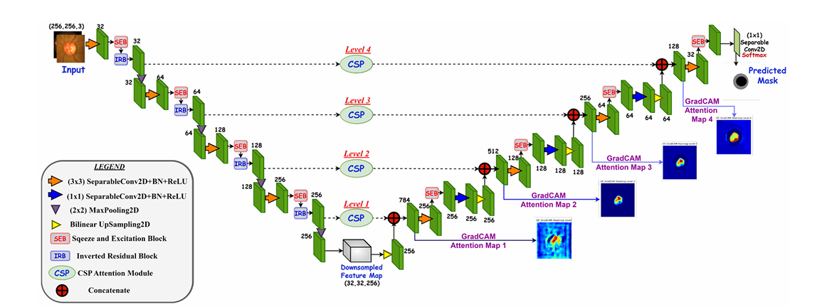
Figure 5.1. Proposed CSP-SegNet+E architecture with RGB+Sobel four-channel input and dual-output segmentation-edge framework.
The figure illustrates the corresponding component of the proposed Report 2 implementation and supports the methodology described in the preceding sections.
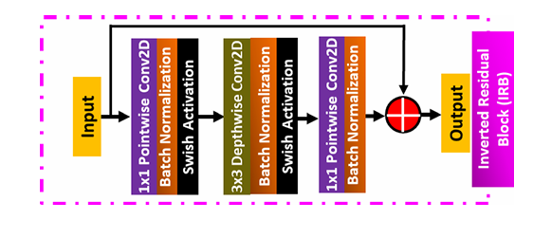
Figure 5.2. Inverted Residual Block (IRB) used in the encoder.
The figure illustrates the corresponding component of the proposed Report 2 implementation and supports the methodology described in the preceding sections.
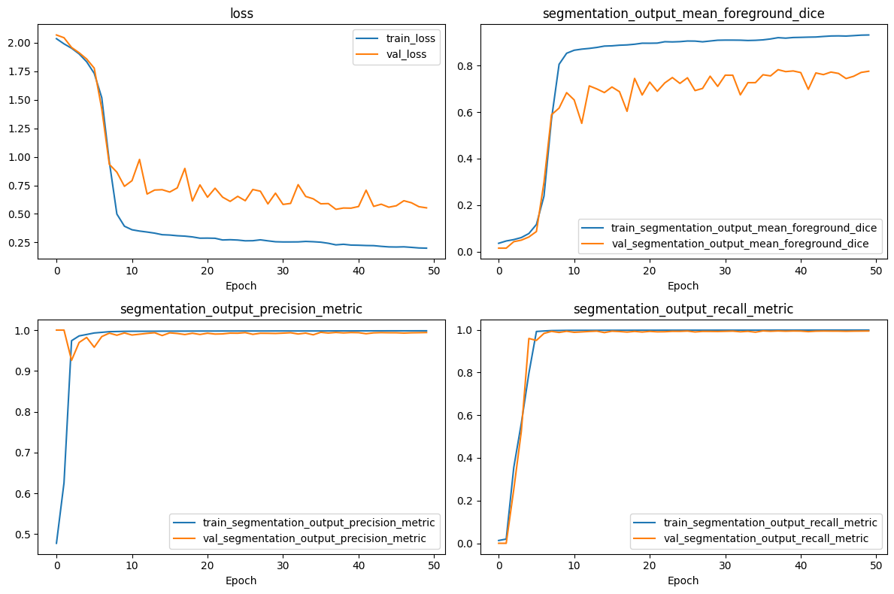
Figure 6.1. Training and validation performance curves.
The figure illustrates the corresponding component of the proposed Report 2 implementation and supports the methodology described in the preceding sections.
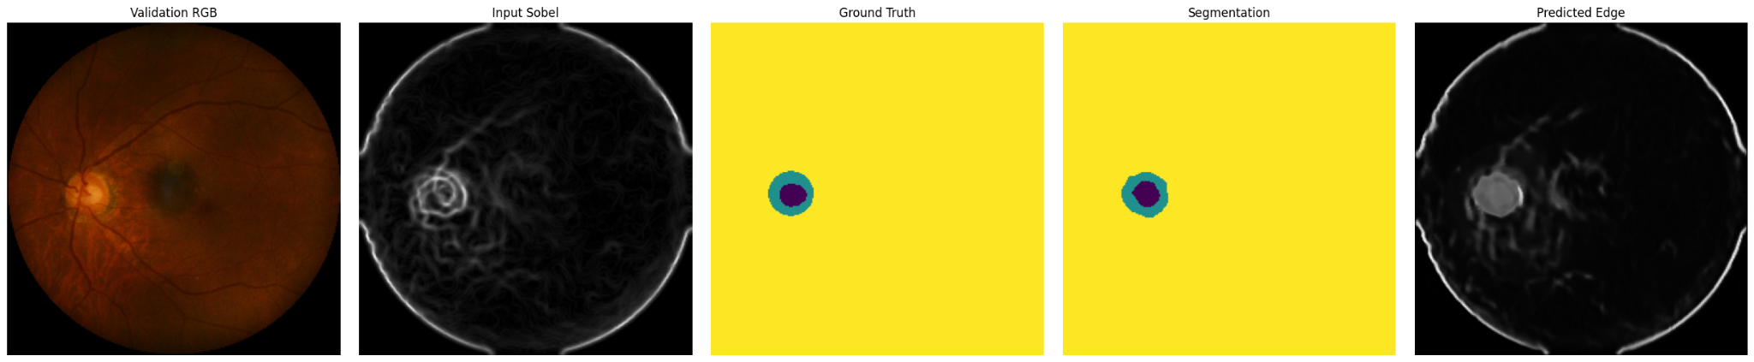
Figure 6.2. RGB fundus image, Sobel edge input, ground truth, segmentation output and predicted edge map.
The figure illustrates the corresponding component of the proposed Report 2 implementation and supports the methodology described in the preceding sections.
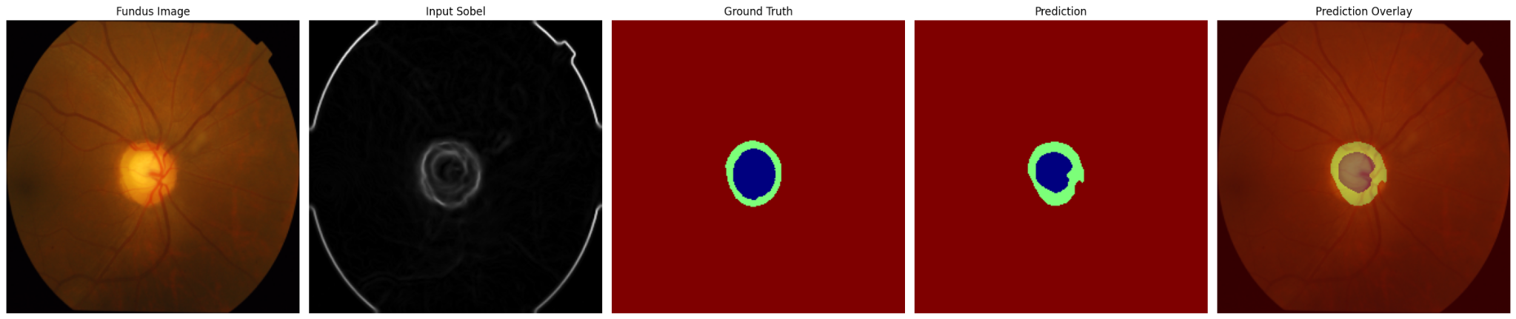
Figure 6.3. Qualitative segmentation results and overlay visualization on DRISHTI-GS.
The figure illustrates the corresponding component of the proposed Report 2 implementation and supports the methodology described in the preceding sections.

